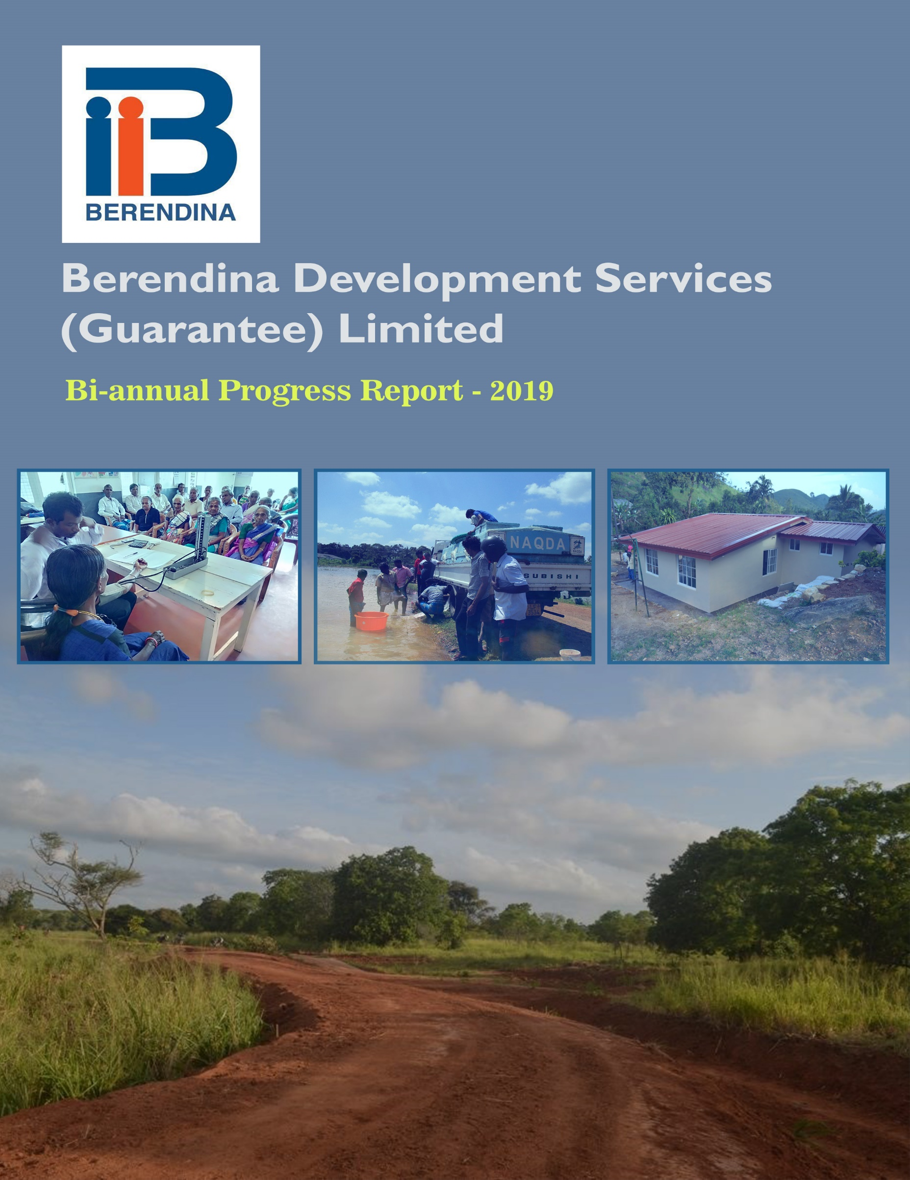

Contents

1. About the Organization 4

2. Strategic Directions 5

3. Partnerships 6

4. Knowledge Management and M&E System (KM/M&E) 8

5. Networking 9

6. Human Resource Management 9

7. Cross Cutting 10

8. Berendina Development Service’s Program 11

9. Project Progress 11

9.1 Plantation Community Empowerment and Development Project – Central Region (B171901) 11

**9.1.1** **Summary of Activities and Progress** 12

9.2 Rural Community Empowerment and Development Project – Central Region (B171902) 17

**9.2.1** **Summary of Activities and Progress** 18

9.3 Rural Community Empowerment and Development Project – North Central Region (B171903) 21

**9.3.1 Summary of Activities and Progress** 22

9.4 Rural Community Empowerment and Development Project – Northern and Eastern Region (B171904) 26

**9.4.1 Summary of Activities and Progress** 27

10. Budget, Income and Expenses Progress 31

About this Report

### This report provides a comprehensive understanding and a detailed analysis of the operations of Berendina Development Services (Guarantee) Limited (BDS) for the period 1st January to 30th June 2019. It discusses the physical progress of the four projects in line with the new strategy (2017-2019) and its three thematic areas, cross-cutting themes and enabling strategies. The report further provides an overview of the financial and non-financial achievements during the reporting period and its impact on the communities.

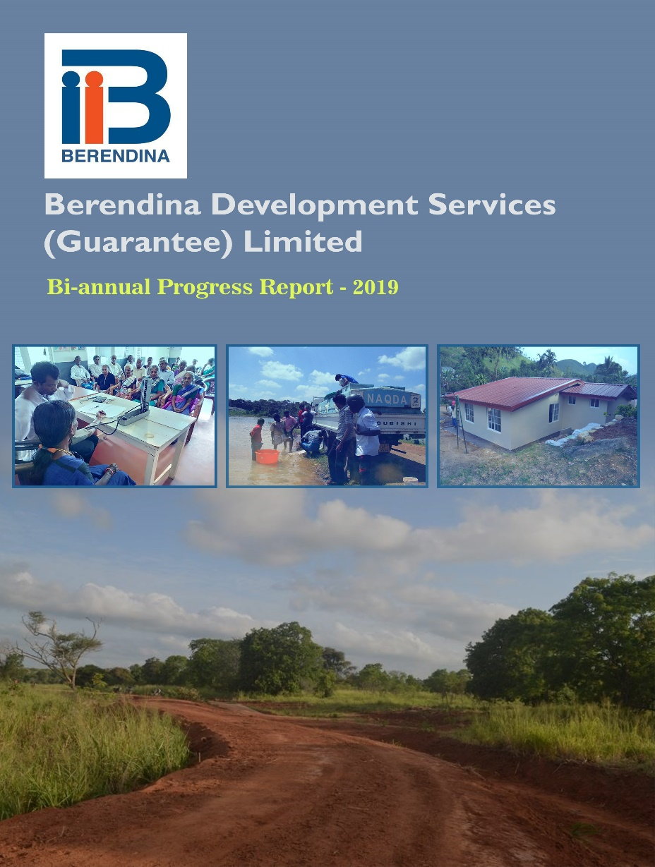

1. About the Organization

Berendina group is one of the leading poverty alleviation agencies in the NGO sector in Sri Lanka and the second largest non-governmental organization which commenced its initial operations in Yatiyanthota in 1987. Berendina has extended its services in the country in Ampara, Anuradhapura, Batticaloa, Kandy, Kegalle, Kilinochchi, Mullaitivu, Nuwara Eliya, Trincomalee and Vavuniya Districts. The group consists of Berendina Development Services (BDS), Berendina Micro Investments Company (BMIC) and Berendina Employment Centre (BEC).

Focusing on the challenges faced by poverty-stricken communities, BDS work to implement sustainable socio-economic projects throughout the rural and plantation sectors communities of the country where BDS is operating. BDS is currently working in six rural districts (Ampara, Anuradhapura, Batticaloa, Kegalle, Mullaitivu, Nuwara Eliya and Trincomalee) and 20 estates in Nuwara-Eliya District, to assist vulnerable and marginalized. The diverse array of projects covers the concerns of Livelihoods, Health, Housing, Sanitation, Social Infrastructure, Clean Water facilitation and Capacity Building of Civil Society Organisations.

1. Strategic Directions

Berendina’s vision is to create an empowered, equitable society where poverty does not exist. Therefore, BDS has identified three interlinked strategic directions that are envisioned to bring about the greatest sustainable change in the lives of the target groups - Vulnerable/ Marginalized Men and Women including Elders, Widows and Persons with Disabilities.

**Strategic Goal:**

“Forty thousand vulnerable/ marginalized families including elders, widows and differently abled persons become socio-economically empowered, realized their rights and opportunities leading towards quality life by 2019”

**Strategic Direction 1**: Vulnerable/ Marginalized Men and Women including Elders, Widows and Persons with Disabilities have increased access to use economic resources, together with active engagements in mainstreamed economic value chains

Under this Strategic Direction, the four projects have successfully reached over 10,000 beneficiary families since inception. Out of which, 1,956 families have been achieved during the reporting period. The program has created income generation opportunities for 149 families during the period. Another 217 beneficiary families were provided access to economic resources through the upgrading of rural economic infrastructure.

**Strategic Direction 2:** Vulnerable/ Marginalized Men and Women including Elders, Widows and Persons with Disabilities have increased access to safe drinking water, sanitation and health services

Communities living in plantation areas and remote rural areas of the country still lack access to quality housing, sanitation, safe drinking water and health care services. Therefore, this strategic direction has a great emphasis on improving the aforementioned conditions among communities. Since inception, the program has reached over 10,900 marginalized families, out of which 753 families have been achieved during the reporting period. Furthermore, there were constructions of houses & toilets in progress for 99 vulnerable/marginalized families as of bi-annual period. Another 278 families have been given access to safe drinking water through newly constructed and upgraded water schemes.

**Strategic Direction 3:** Vulnerable/ Marginalized Men and Women including Elders, Widows and Persons with Disabilities realized and enjoying their rights through advocacy and lobbying efforts together with civil society strengthening, capacity building and meaningful participation

Majority of plantation and rural communities are unaware of their rights and often do not have the opportunity to raise their voice. Grass root level Civil Society Organizations (CSO) are the only existing avenue they have to raise their voice. Nevertheless, these CSOs do not have the necessary skills or capacity to advocate local authorities regarding prevailing community issues. As a result, these marginalized communities are often excluded from the decision-making process and their voices remain unheard to relevant authorities. Therefore, this strategic direction plays a significant role in empowering marginalized communities in a sustainable manner. So far, the program has empowered over 7,000 community members out of which 2,373 members were reached during the period under review. A range of program interventions such as capacity building training for CSO leaders, awareness creation on civil rights and legal support was provided to these CSOs.

1. Partnerships

**1. Strategic Partnerships:**

In line with the 2017-2019 strategic plan BDS works with a number of partners to develop long-term relationships, share resources and exchange knowledge, thereby creating a greater impact on the most vulnerable and marginalised communities.

**Details of partners in 2019**

|  |  |  |
| --- | --- | --- |
| Type of Organization | Name of the Partner | Interventions |
| Government | Ministry of Hill country, New Villages, Infrastructure and Community Development | Construction ongoing for 20 houses in Katabola estate. Total value of the construction is LKR 19 Mn. |
| National Water supply and Drainage Board | Provision of individual water connections to eligible beneficiaries and identification of locations to install Reverse Osmosis (RO) plants in Anuradhapura and Trincomalee Districts. |
| National Aquaculture Development Authority (NAQDA) | Stocked fingerlings in 14 minor irrigation tanks in Anuradhapura, Trincomalee and Mullaitivu Districts, where fingerlings were provided from NAQDA. Technical training was also given to Farmer Organizations on best practices on aquaculture. |
| Irrigation Department – Sri Lanka | The administration of minor irrigation tanks usually come under the Department of Agrarian Development. However, some of the minor irrigation structures also come under the Irrigation Department. Therefore, the Irrigation department provided technical assistance to renovate minor irrigation tanks in Anuradhapura, Mullaitivu, Trincomalee and Batticaloa Districts. |
| Department of Agriculture | Provided technical assistance and further provided resource persons to conduct trainings. |
| Department of Agrarian Development | Minor irrigation structures were renovated in Trincomalee, Mullaitivu Anuradhapura and Batticaloa Districts. |
| Department of Labour | One TOT program on EPF/ETF claiming procedures for EMAs, child development officers, welfare officers, subject clerks and project staff in Nuwara Eliya District. |
| Registrar General’s Department | Provided birth certificates, marriage certificates and national identity cards to plantation workers. one awareness sessions conducted on the importance of basic legal documents for 71 plantation workers. |
| District and Divisional Secretariat Offices | Provided necessary approvals and recommendations to implement project activities in all working districts. |
| Medical Officer of Health | Implementation of Health and sanitation interventions in both rural and plantation areas. Further conducted trainings in both rural and plantation areas. |
| Department of Samurdhi development | Partnered in constructing two houses in Trincomalee. |

| Type of Organization | Name of the Partner | Interventions |
| --- | --- | --- |
| Non-Government | World Vision Lanka | Provided financial assistance to construct houses and toilets in plantation estates. Water project was in progress in Kotiyagala estate and another 4 to be initiated in Mattakelle, Velioya, Drayton and Lonach estates. |
| PLAN international | Collaborated to implement the Federal Ministry for Economic Cooperation and Development (BMZ) funded grant – “Strong women and youth in rural entrepreneurship and civil society in Sri Lanka” |
| Lanka Harness | Created employment opportunities for rural communities in Yatiyanthota. |
| AmSafe Bridport | Created employment opportunities for rural communities in Yatiyanthota, Dehiowita and Kithulgala DSDs. |
| Okaya Lanka | Created employment opportunities for rural communities in Yatiyanthota. |

1. Knowledge Management and M&E System (KM/M&E)

In 2017, BDS established a separate monitoring & evaluation unit with staff located both in the head office and in regional offices at Ginigathhena and Trincomalee. During the same year, M&E unit successfully completed developing the log frame and M&E plan for all four projects, which was followed by the baseline surveys. Meanwhile the annual monitoring survey has been commenced during the reporting period in order to measure the impact of four projects. The survey was supposed to complete before the start of external evaluation in late August.

The M&E unit initially planned to measure the progress of the four projects separately, and relevant monitoring tools and databases were developed for the four projects separately. Upon testing these tools, it was later realized that all four monitoring databases can be merged together as one, thus making the process of measuring at national level more convenient. The progress reports however, have to be generated manually since all databases utilized in the past and present are developed using Microsoft Excel.

1. Networking

BDS engages with a number of stakeholders in implementing projects, and the success of interventions are based on these long-standing relationships. These stakeholders include government officers and representative from the ministries, INGOs, NGOs, private sector and donors. BDS takes initiatives to engage with its stakeholders, formally and informally to ensure these relationships are carried forward to the future. Lessons learnt events are conducted to exchange knowledge, learn from like-minded development practitioners and create visibility of BDS work. BDS attends monthly NGO forums held at district level to learn the work of other like-minded NGOs which opens avenues for partnership opportunities, while avoiding duplication of work. BDS also represents the divisional level committees of Divisional secretariat offices and participates in monthly meetings, further enhancing opportunities for partnerships through networking.

1. Human Resource Management

As of June 2019, BDS has a staff capacity of 47. Out of which 28 % are female staff. The staff turnover from January to June 2019 was 36%. Total number of permanent staff are 18.

**Staff Training and Development**

New recruits who join with Berendina were given induction training. This training enables them to familiarize with the organization’s mission, vision, objectives, rules and regulations and the working conditions. When current employees are promoted or given a career growth opportunity, relevant trainings and exposure is provided in order to prepare them to undertake higher level responsibilities. Through these trainings, BDS expects to increase efficiency and productivity of employees, thereby reducing the need for constant supervision. Furthermore, it also creates avenues for promotions and to take up larger responsibilities. Thus, becoming an asset to the organization.

During the period of reporting a fire training was organized to HO staff by Berendina in order to give a practical Knowledge how to act and procedures to be followed when in an occasion of fire. This was done by the Fire Department of Municipal Council, Kotte and hands on training was provided to employees in case of using fire extinguishers and how to act during a practical situation.

Further a motivational training by Mr. Dammika Kalapuge was organized by Berendina for all Sinhala speaking staff including HO and field staff in order to encourage employees to make valuable contributions in their company's targets and participate in administrative tasks. It makes them loyal towards the organization and brings workforce stability.

A training on value chain development was conducted to Berendina staff in March 2019 in a three-day workshop (21st – 23rd March 2019). Topics were the concept of value chain development, segment and process of value chain development. Altogether 36 staff including BMZ project participated for the program.

**Formulation of New Policies**

Gender Policy

Berendina organization is explicitly committed to support gender equity and equality and women empowerment as outlined in the international conventions and national policy frameworks. With that hope Berendina developed Gender Policy to establish a clear vision and make commitments to guide the process of gender mainstreaming and women empowerment to influence procedures and practices which will accelerate the achievement of gender equality, gender justice in executing its services.

Anti-Harassment and Anti Sexual Harassment Policy

Further, Berendina is committed to fostering a harassment-free workplace where all employees are treated with respect, dignity and justice. Harassment at Berendina will not be tolerated. For the above purpose Berendina is all set to adopt the anti-harassment and anti-sexual harassment policy.

1. Cross Cutting

## Gender Mainstreaming

When implementing interventions related to economic development, BDS paid a special emphasis on women. During the reporting period, BDS identified two potential livelihood groups to provide an additional income for 30 marginalized women in Batticaloa district through Palmyra based production. BDS also conducted one awareness sessions on gender-based violence for 30 participants in Ambagamuwa Divisional Secretariat.

1. **Environment**

All activities carried out by BDS are environment sensitive and is focused on sustainability. Therefore, BDS has not initiated activities that can potentially harm the environment. During construction processes specially in water, housing and infrastructure projects, BDS obtained environmental reports from relevant authorities to be more considerate of the environment.

1. **Disaster Response**

Responding to disasters is an essential part of BDS’s work. In 2017 BDS has initiated more work in relation to disaster response in various parts of the island, especially due to the flood and prolong drought. BDS has the ability to respond to such situations effectively. Therefore, BDS has allocated rupees one million of its budget as a contingency fund, which will only be used to respond to such natural disasters in 2019. However, this budget remained unspent during the period under review since there were no major disasters during the same period.

1. Berendina Development Service’s Program

BDS’s programs for socio-economic development has been constantly evolving over the decades, responding to the changing environment in which we are working and the lessons that we learned from our work and the work of others. Projects designing process in 2016 BDS took its stock of current programs, our working environment and our best predictions where the country is heading towards the upcoming three years. Four projects have been developed for rural and plantation communities.

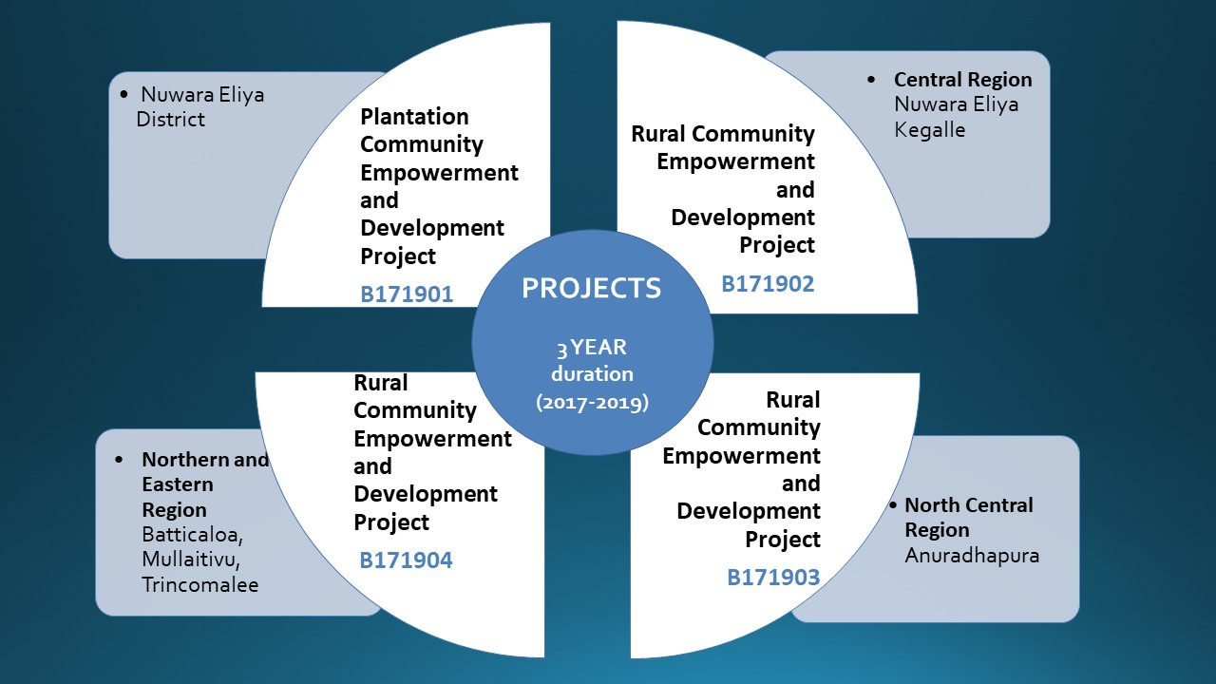

1. Project Progress

## Plantation Community Empowerment and Development Project – Central Region (B171901)

The Goal of the project is: **15,000 vulnerable families** including elders, widows and differently abled persons in selected estates **improved their living conditions** including health and enjoying their rights by December 2019.

The key to achieving the goal of the project is through strengthening the capacity of the social institutions and enhance their services to the community. BDS will adopt both direct implementation and strategic partnership approaches in delivering the project outputs. The project has two outcomes that contribute achieving the goal.

1. Ensure access to and use of safe drinking water, sanitation, housing, health and health infrastructure facilities – SD-02
2. Strengthened capacity of local institutions/ CBOs (elders ‘clubs, water committees, and Differently abled persons’ society) to provide better services to plantation community and to voice for their basic rights – SD-03

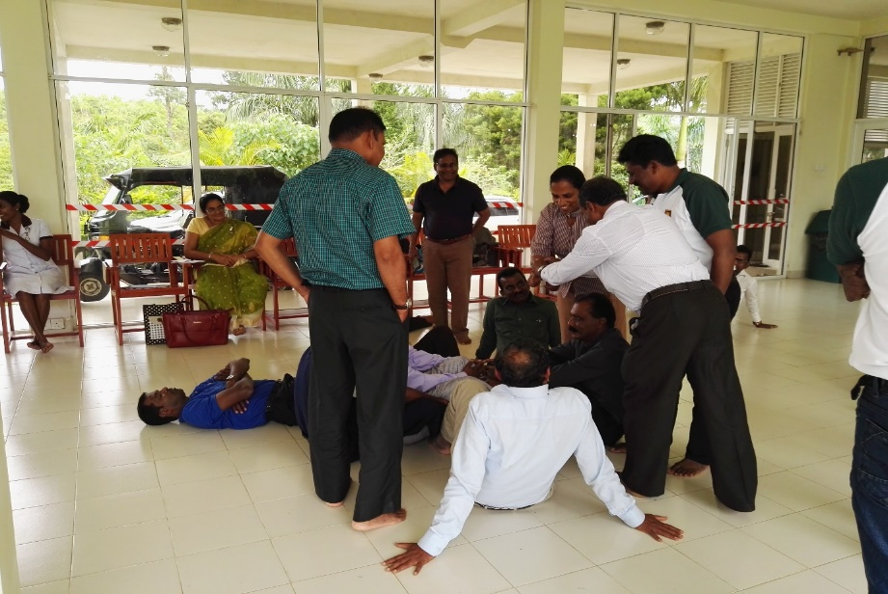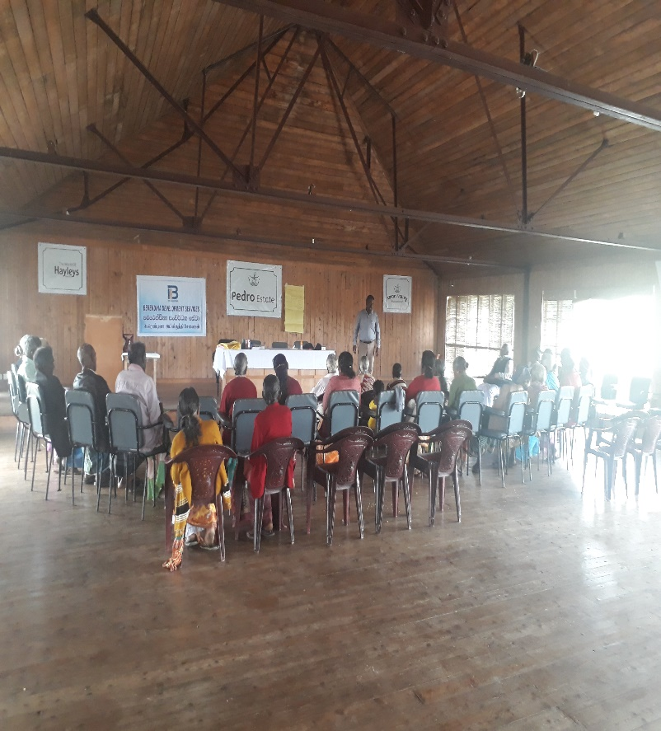

EMA Trainings in NCM Training Centre, Hatton

Elders' clubs Capacity Building Trainings in Pedro Estate

### **Summary of Activities and Progress**

| **Indicator** | **Annual Target** | **6th month Target** | **6th month Achieved** | **6th month Achievement vs. Target** | **Variance Explanation** |
| --- | --- | --- | --- | --- | --- |
| Output 1.1 - Knowledge of the beneficiaries on best hygiene practices and available government health services are improved | | | | | |
| # of awareness on best hygiene practices (personal hygiene, environmental hygiene) conducted | 2 | 2 | 4 | 200% |  |
| # of beneficiaries participated to hygiene awareness sessions | 60 | 60 | 125 | 208% |  |
| # of awareness program conducted for elders clubs regarding non-communicable disease (NCD) and good health habits. | 5 | 5 | 4 | 80% |  |
| # of elders participated for awareness sessions on NCDs and Communicable Disease(CD)s | 150 | 150 | 256 | 171% |  |
| Output 1.2 - Knowledge of EMAs on the updated medical practices improved | | | | | |
| # of capacity building trainings conducted for EMAs | 5 | 3 | 3 | 100% |  |
| # of EMAs attended to the program | 175 | 105 | 91 | 87% |  |
| Output 1.3 – Health Infrastructure facilities within the estates improved | | | | | |
| # of Dispensaries constructed/ renovated | 2 | 1 | 0 | 0% | Projects identified and plan to complete the work during next reporting period |
| # of beneficiaries benefitted from the improved infrastructure | 400 | 200 | 0 | 0% | Benefit could be measured after the completion of tasks |
| Output 1.4 - Access to safe drinking water, sanitation and housing facilities are improved | | | | | |
| # of water schemes constructed | 3 | 1 | 0 | 0% | All tasks have been identified and implementation is in progress |
| # of beneficiaries benefitted under each water schemes | 300 | 100 | 0 | 0% |  |
| # of awareness sessions conducted on maintenance of water schemes | 10 | 7 | 1 | 14% | This has been scheduled and to be conducted in 3rd and 4th quarters. |
| # of water committee members participated to awareness sessions on maintenance | 350 | 245 | 27 | 11% |  |
| # of follow up activities conducted of previously established water schemes | 3 | 3 | 0 | 0% | Inspections have been done to identify the issues in the previously established water schemes. At the same time, estimate for one project is completed and ready for implementation. |
| # of toilets constructed for vulnerable families on grant basis | 25 | 23 | 0 | 0% | Seven constructions are in progress and expect to complete by end of the year |
| # of toilets constructed in partnership with other institutions | 200 | 135 | 0 | 0% | Seventy constructions in progress and expect to complete by end of the year |
| # of houses constructed on grant basis | 8 | 8 | 0 | 0% | Eight identified and two are ongoing and expect to complete by end of the year |
| Output 1.5 - Increased Hemoglobin (Hb) level of estate female workers | | | | | |
| # of *Hb* screening programs conducted | 24 | 24 | 44 | 183% |  |
| # of participants for screening program | 1,200 | 1,200 | 2,278 | 190% |  |
| # of female workers received medicines to improve *Hb* level | 2,500 | 2,500 | 877 | 35% | Only females below Hb level 11.5mg/dl were provided medicine. |
| # of awareness program on food intake habit conducted | 72 | 63 | 36 | 57% | It was difficult to take appointments from EMAs. |
| # of participants for awareness program on food intake habit | 2,500 | 2,205 | 1,739 | 79% |  |
| Output 1.6 - Eye sight of elders are improved | | | | | |
| # of awareness programs conducted for elders regarding good eye sights and cataract | 16 | 16 | 16 | 100% |  |
| # of participants for awareness sessions | 480 | 480 | 507 | 106% |  |
| # of cataract surgeries completed for elders | 150 | 125 | 87 | 70% |  |
| Output 2.1 - Increased the organizational capacity of existing/ newly formed Elders clubs, Water committees, Differently Abled persons’ to provider better services | | | | | |
| # and types of recreational activities conducted by elders clubs | 26 | 22 | 18 | 82% |  |
| # of participants for recreational events | 910 | 770 | 609 | 79% |  |
| # of capacity buildings for Elders clubs | 30 | 10 | 21 | 210% |  |
| # of participants in the capacity building programs | 1050 | 350 | 759 | 217% |  |
| # of elders clubs received grant facilities, furniture, musical equipment for recreational activities | 20 | 20 | 0 | 0% | Any CBO for which the assessment was done, did not fulfill required level of eligibility. |
| # of vulnerable destitute families received monthly allowance from BDS and cared by CBOs | 153 | 153 | 153 | 100% |  |
| # of PWD district forum meetings conducted | 4 | 2 | 2 | 100% |  |
| # of PWDs participated in district forum meetings | 100 | 50 | 49 | 98% |  |
| # of trainings conducted for govt. & NGO staff on community based PWD inclusive development | 1 | 1 | 1 | 100% |  |
| # of trainings conducted for plantation staff on community based PWD inclusive development | 1 | 0 | 0 | - |  |
| Identify the location for construct common access (Audit) | 1 | 1 | 1 | 100% |  |
| # of common access structures built for PWDs in public places | 6 | 0 | 0 | - | All these have been identified and completed by end of this year |
| # of PWD databases created | 1 | 0 | 0 | - |  |
| Output 2.2 - Increased accessibility of obtaining basic documents through local institution/ partners | | | | | |
| # of mobile programs conducted to obtain basic documents | 10 | 8 | 3 | 38% | Two programs are scheduled to conduct during July and September |
| # of awareness sessions conducted to minimize issues of basic legal documents | 10 | 4 | 4 | 100% | 242 participants were benefitted |
| Output 2.3 - Process of claiming Employee Providence Fund(EPF)/Employee Truest Fund(ETF) is strengthened through advocacy efforts | | | | | |
| # of awareness program conducted for workers on the process of claiming EPF/ETF | 10 | 4 | 8 | 200% |  |
| # of workers attended to awareness on EPF/ETF | 500 | 200 | 229 | 115% |  |
| # of capacity building trainings conducted for subject clerks | 5 | 3 | 1 | 33% | Taking appointments from ACL was difficult. |
| # of subject clerks participated | 75 | 45 | 31 | 69% |  |
| # of mobile programs conducted to address their existing EPF issues with Central Bank. | 1 | 0 | 0 | - |  |
| # of participants | 50 | 0 | 0 | - |  |
| Output 2.5 - Community infrastructures facilities and accessibility within the estates improved. | | | | | |
| # of infrastructures improved/ newly constructed | 15 | 13 | 0 | 0% | Projects have been identified and those will be completed by October |
| # of beneficiaries benefitted from the improved infrastructure by types and gender | 750 | 650 | 0 | 0% |  |

## Rural Community Empowerment and Development Project – Central Region (B171902)

The goal of the project is “**6,000 vulnerable families in *Nuwara-Eliya* and *Kegalle* districts including elders, widows and differently abled person have attained improved and sustainable level of socio-economic conditions and enjoying their rights by December 2019**. The project will work in Ambagamuwa DS Division in Nuwara Eliya District and Dehiovita DS Division in Kegalle District.

The outcomes of the project are;

1. Increased family income of farming communities – SD-01
2. Ensure access to and use of safe drinking water, sanitation, housing, health and health infrastructure facilities – SD-02
3. Strengthened capacity of local institutions/CBOs (elders’ clubs, water committees, and Differently abled persons’ society) to provide better services to plantation community and to voice for their basic rights – SD-03

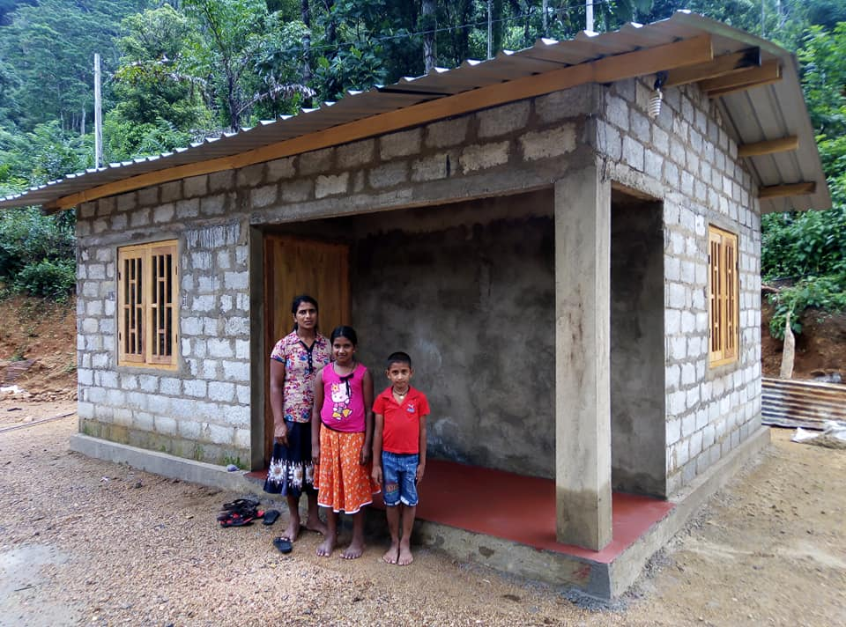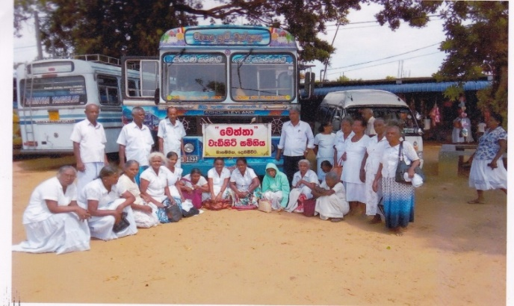

Pilgrimages of Elders’ club of Magammana GND

House construction of Mrs H.M. Gunarathna manike at Kalaweldeniya Grama niladhari division

### **Summary of Activities and Progress**

| **Indicator** | **Annual Target** | **6th month Target** | **6th month Achieved** | **6th month Achieved vs. Target** | **Variance Explanation** |
| --- | --- | --- | --- | --- | --- |
| Output 1.1 - Increased skills/knowledge of vulnerable families to enhance the productivity of the Income generation activities | | | | | |
| No. of trainings conducted on new/ improved techniques (Post harvesting/crop diversification, inter cropping, land use efficiency, water management) | 20 | 10 | 13 | 130% |  |
| No. of participants for the trainings | 700 | 350 | 406 | 116% |  |
| No. of trainings conducted on value addition for the produces | 5 | 4 | 0 | 0% | Value addition trainings will be conducted during 3rd and 4th quarter. |
| No. of participants for the value addition trainings | 150 | 120 | 0 | 0% |  |
| Output 1.2 - Increased income of the vulnerable families through strengthening and active participation in the selected value chains | | | | | |
| No. of value chain interventions started | 1 | 1 | 0 | 0% | Value chain analysis was not possible during the reporting period. |
| No. of households engaged in income generating activities through value chain interventions | 50 | 50 | 0 | 0% |  |
| Output 1.3 - Livelihood producer groups formed and actively functioning | | | | | |
| No. of household money management trainings conducted | 10 | 4 | 3 | 75% | 81 participants were trained on household money management |
| Output 1.4 - Private sector activity promoted at divisional and district level through social business approach | | | | | |
| No. of social business producer groups/ production centers established | 2 | 1 | 0 | 0% | Cargo net production center has been identified so the activity will start in September. |
| No. of employment opportunities generated through social business approach since 2019 | 50 | 25 | 0 | 0% | There will be 21 employments created soon. |
| No. of employment opportunities generated through social business interventions before 2019 | 100 | 100 | 108 | 108% |  |
| Output 2.1 - Access to safe drinking water are improved | | | | | |
| No. of water schemes upgraded to cater more families | 2 | 1 | 0 | 0% | Construction of Morahenegama water project is ongoing |
| No. of beneficiaries benefitted under each water schemes | 200 | 100 | 0 | 0% |  |
| Output 2.2 - Access to sanitation and housing facilities are improved | | | | | |
| No. of toilets constructed for vulnerable families on grant basis | 17 | 9 | 0 | 0% | 6 toilet constructions are on going |
| No. of houses constructed on grant basis in partnership with other institutions | 4 | 2 | 0 | 0% | 3 house constructions are ongoing |
| Output 3.1 - Capacity & knowledge of existing or new CBOs strengthened and provide better services to the community | | | | | |
| No. of Senior Citizens’ Club(SCC)s strengthened and supported through BDS | 30 | 15 | 31 | 200% |  |
| No. of vulnerable destitute families received monthly allowance from BDS and cared by CBOs | 125 | 125 | 125 | 100% |  |
| Output 3.2 - Increased understanding of social positions and rights among various ethnic communities and groups. | | | | | |
| No. of gender-based violence awareness programs conducted | 12 | 8 | 3 | 38% | Target will be achieved by end of the year as the training plan is developed to conduct during October |
| No. of participants for gender-based violence awareness programs | 360 | 240 | 81 | 34% |  |
| Output 3.3 - Community infrastructures improved through active engagement by CBOs | | | | | |
| No. of community infrastructures renovated/ newly constructed | 2 | 2 | 1 | 50% | One more construction has been identified in Dehiowita |
| No. of beneficiaries benefitted from the improved infrastructure | 100 | 100 | 50 | 50% |  |

**Case Study 2**

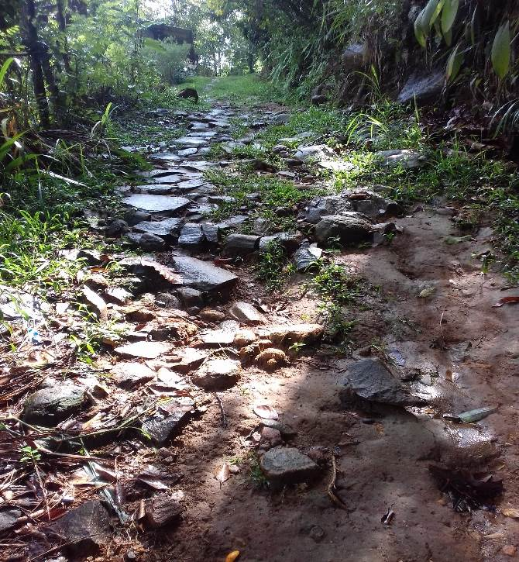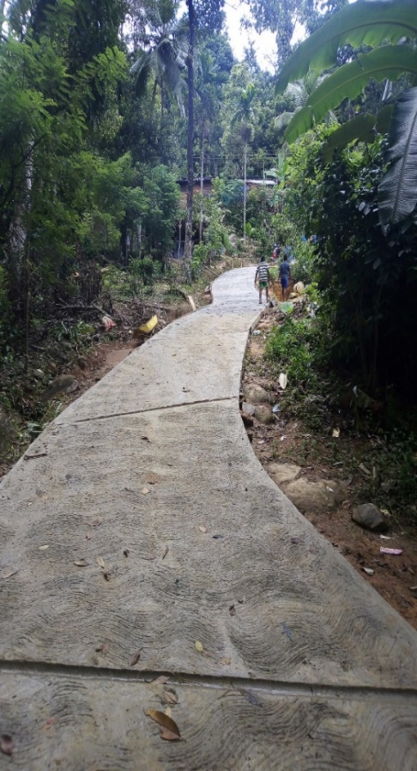Ambathalawa Govi Janapadaya is located in Dehigasthenna Grama Niladhari Division in Ambagamuwa DSD in Nuwara Eliya District. Fifty families in the area had faced difficulties in their travel and transportation due to the fact that the road they use namely Godagedara road was in a dilapidated condition without any repairs made for a long time. Using this road was a big challenge for day-to-day activities of all the villagers. This was the road used by farmers to transport their produce to the market as well as the only option for school children, elders and disabled people to reach the main road. During rainy seasons, the road became more challenging to use by becoming muddy and dangerously slippery. Samagi Rural Development Society in Ambathalawa Govi janapadaya village, in collaboration with Berendina contributed in solving the grief of the village and constructed a concrete road in a short period of time with a total cost of LKR 710,000. Now the villagers are relieved from their misery and so happy to use the newly constructed road, which enable all to use it for all their transportation requirements.

## Rural Community Empowerment and Development Project – North Central Region (B171903)

The goal of the project is to **enhance socio economic status of 6,500 vulnerable and marginalized people in north central region** while **enjoying their rights by December 2019**.The project will work in Manupa, Kahatagasdigiliya and Horrowpathana DS Divisions in Anuradhapura District.

The key to achieving the goal of the project is through strengthening the capacity of the social institutions and enhance their services to the community. BDS will adopt both direct implementation and strategic partnership approaches in delivering the project inputs. The project has three outcomes that contribute achieving the goal.

1. Increased family income of farming and fishing communities – SD-01
2. Ensure access to and use of safe drinking water, sanitation, housing, health and health infrastructure facilities – SD-02
3. Strengthened capacity of local institutions/ CBOs (elders ‘clubs, water committees, and Differently abled persons’ society) to provide better services to plantation community and to voice for their basic rights – SD-03

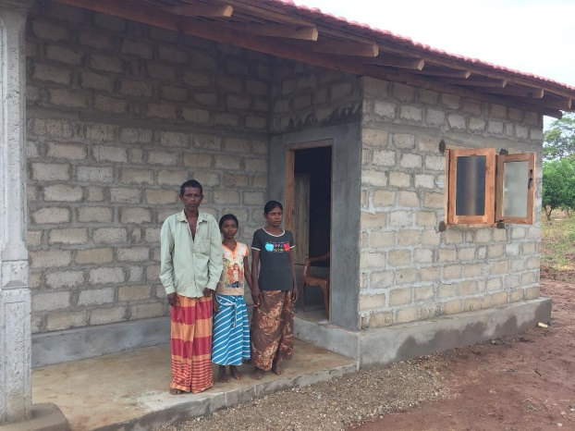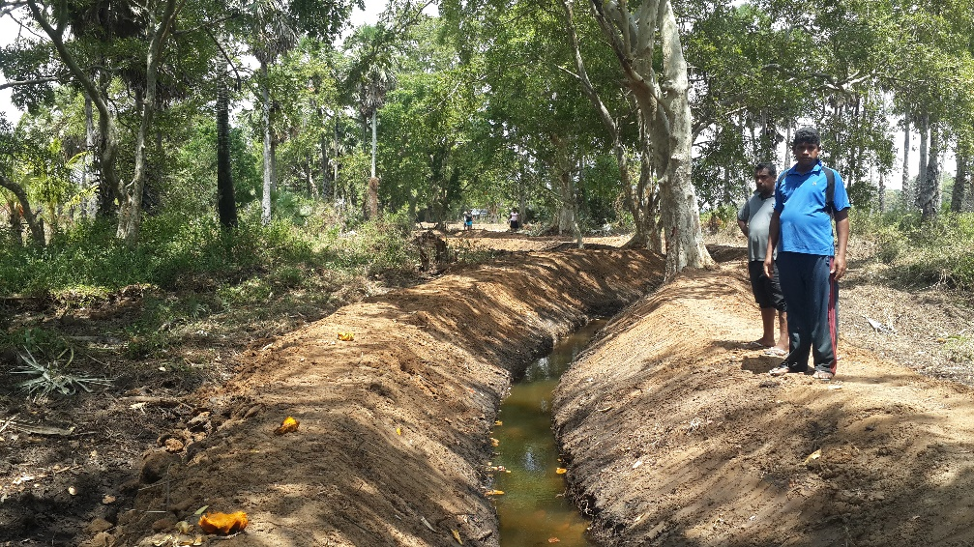

House Construction for a PWD, Mr. Siripala in Gambirigaswewa

Field canal, Kokkichchiya, Elayapattuwa, Anuradhapura

### **9.3.1 Summary of Activities and Progress**

| **Indicator** | **Annual Target** | **6th month Target** | **6th month Achieved** | **6th month Achieved vs. Target** | **Variance Explanation** |
| --- | --- | --- | --- | --- | --- |
| Output 1.2 Upgraded economic rural infrastructures through community participation | | | | | |
| No. of rural economic infrastructures upgraded/constructed with CBO participation | 22 | 15 | 2 | 13% | 16 constructions have been identified and 9 are ongoing |
| No. of community members benefited through upgraded/constructed economic infrastructures | 1300 | 880 | 137 | 16% |  |
| Output 1.3 Increased market accessibility through reliable market linkages while upgrading existing infrastructure facilities | | | | | |
| No. of technical trainings provided on value addition | 3 | 3 | 0 | 0% | Sessions need to be organized and training will be conducted during October |
| No. of farmers participated on trainings conducted on value addition | 60 | 60 | 0 | 0% |  |
| No. of FOs/FMSs received tools to reach markets through private partnerships (facilitate storage, facilitate out grower system) | 3 | 2 | 2 | 100% |  |
| No. of farmers benefited through private partnerships | 60 | 40 | 21 | 53% |  |
| Output 1.4 Increased alternative income sources based on local potentials & availability of resources | | | | | |
| No. of tanks stocked fingerlings | 12 | 12 | 10 | 83% |  |
| No. of fingerlings stocked | 300,000 | 300,000 | 190,000 | 63% |  |
| No. of farmer/fisheries families benefited due to stocking of fingerlings | 700 | 700 | 659 | 94% |  |
| No. of beneficiaries received inputs for group based alternative LH activities | 100 | 50 | 3 | 6% | Most of the livelihood projects identified in the area were Aloe vera cultivations and since this was a pilot project, this was purposely delayed until see the progress. |
| Creation of income generation opportunities through social business approach | 2 | 2 | 0 | 0% | Projects identified on promoting evening milk collection and inland fishing and initial works have been done so expect to implement during October |
| No. of beneficiaries received income generation opportunities through social business approach | 150 | 150 | 0 | 0% |  |
| Output 2.1 Improved access to sanitation and housing facilities | | | | | |
| No. of toilets constructed | 20 | 12 | 1 | 8% | Eleven identified and 3 in progress |
| No. of houses constructed | 13 | 8 | 0 | 0% | Twelve identified and 4 in progress |
| Output 2.2 Increased availability of safe drinking water through social business approach & upgrading existing water schemes | | | | | |
| No. of RO plants installed | 3 | 2 | 2 | 100% |  |
| No. of families gained access to safe drinking water through RO plants | 500 | 330 | 250 | 76% |  |
| No. of existing drinking water sources renovated | 3 | 2 | 0 | 0% | Two project have been identified |
| No. of families gained access to safe drinking water through renovated water sources | 120 | 80 | 0 | 0% |  |
| Output 2.3 Improved required health infrastructures through community participation | | | | | |
| No. of health infrastructures renovated/constructed with partnerships | 3 | 2 | 1 | 50% |  |
| No. of families benefitted due to provision of essential tools for health centers | 200 | 130 | 100 | 77% |  |
| Output 3.1 Improved human capacity of existing CBOs | | | | | |
| No. of capacity building trainings conducted for CBOs | 9 | 3 | 0 | 0% | All the training are scheduled to conduct during 3rd and 4th quarter as the staff mostly involved in construction related projects. |
| No. of participants in capacity building trainings for CBOs | 300 | 100 | 0 | 0% |  |
| No. of workshops conducted on positive attitudes/behavioral changes of office bearers | 3 | 3 | 0 | 0% | All the training are scheduled to conduct during 3rd and 4th quarter as the staff mostly involved in construction related projects. |
| No. of participants in workshops conducted on positive attitudes | 500 | 500 | 0 | 0% |  |
| No. of SCC strengthened and supported through BDS | 11 | 3 | 0 | 0% | This will be conducted without the partnership during 4th quarter |
| No. of vulnerable families provided monthly allowance | 100 | 100 | 152 | 152% |  |
| Output 3.2 Improved structural capacity of existing CBOs | | | | | |
| No. of CBOs received essential resources (furniture, tools and stationary) | 9 | 4 | 2 | 50% | These CBOs are identified and the task will be completed in September |
| Output 3.3 Reduced dependency of differently abled people & society of disabled people | | | | | |
| No. of district level coordination meeting facilitated | 6 | 2 | 0 | - | This has been planned and the meeting will be conducted as planned. |
| No. of access facilities constructed for PWD | 4 | 0 | 0 | - | Projects are identified and these will be completed in 4th quarter |
| No. of PWDs received support | 200 | 0 | 0 | - |  |
| No. of database developed/ book published with latest data on PWD | 1 | 0 | 0 | - | Initial discussion with the relevant authority is being conducted and expected to complete within this year |

**Case Study 3**

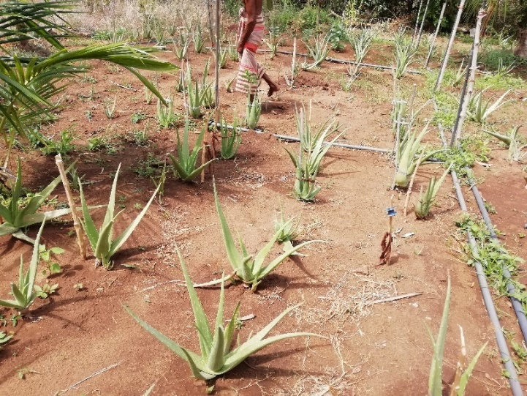Aloe Vera is a popular medicinal plant and one of the most profitable business now a day, which can be produced in the farm lands as it grows faster in few months and doesn’t require special attention for its growth. Under the group based livelihood intervention, Berendina Development Services (BDS) provided Aloe Vera plants to 30 farmer beneficiaries, selected from Mahahatuwewa, Viharahalmillakulama and Ilandagahawewa areas. Each beneficiary was provided with 500 Aloe Vera plants. The beneficiaries were also provided with special training on how to nurture the plants and soil preparation. This successful intervention has made the Aloe Vera farmers to have around five healthy harvesting rounds. Though there are considerable price fluctuations in market, they were able to sell for an average price of LKR 40 per Kilogram.

This particular project was planned informing the beneficiary at the inception that equal number of suckers to the number of plants they have been provided will be collected from them once the cultivation is established well. Based on that, 770 Aloe Vera plant suckers were collected from Mahaahatuwewa farmers for the second round of distribution. These plants were given to another group of three farmers, 256 plants per each, making this initiative a sustainable project.

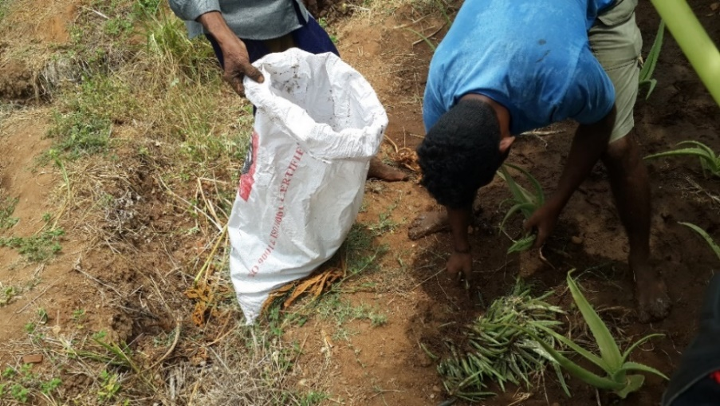

BDS is willing to expand Aloe Vera cultivation successfully to other areas as well if new farming community is ready to take the challenge. At present, Aloe Vera farmers are earning an average of LKR 4000 per month which is a huge relief for them to get rid of their present financial struggles. Through this intervention, BDS hope to make this valuable herbal plant popular among the farming community while strengthening their economy by opening a door for them to earn extra income with this crop.

**Case Study 4**

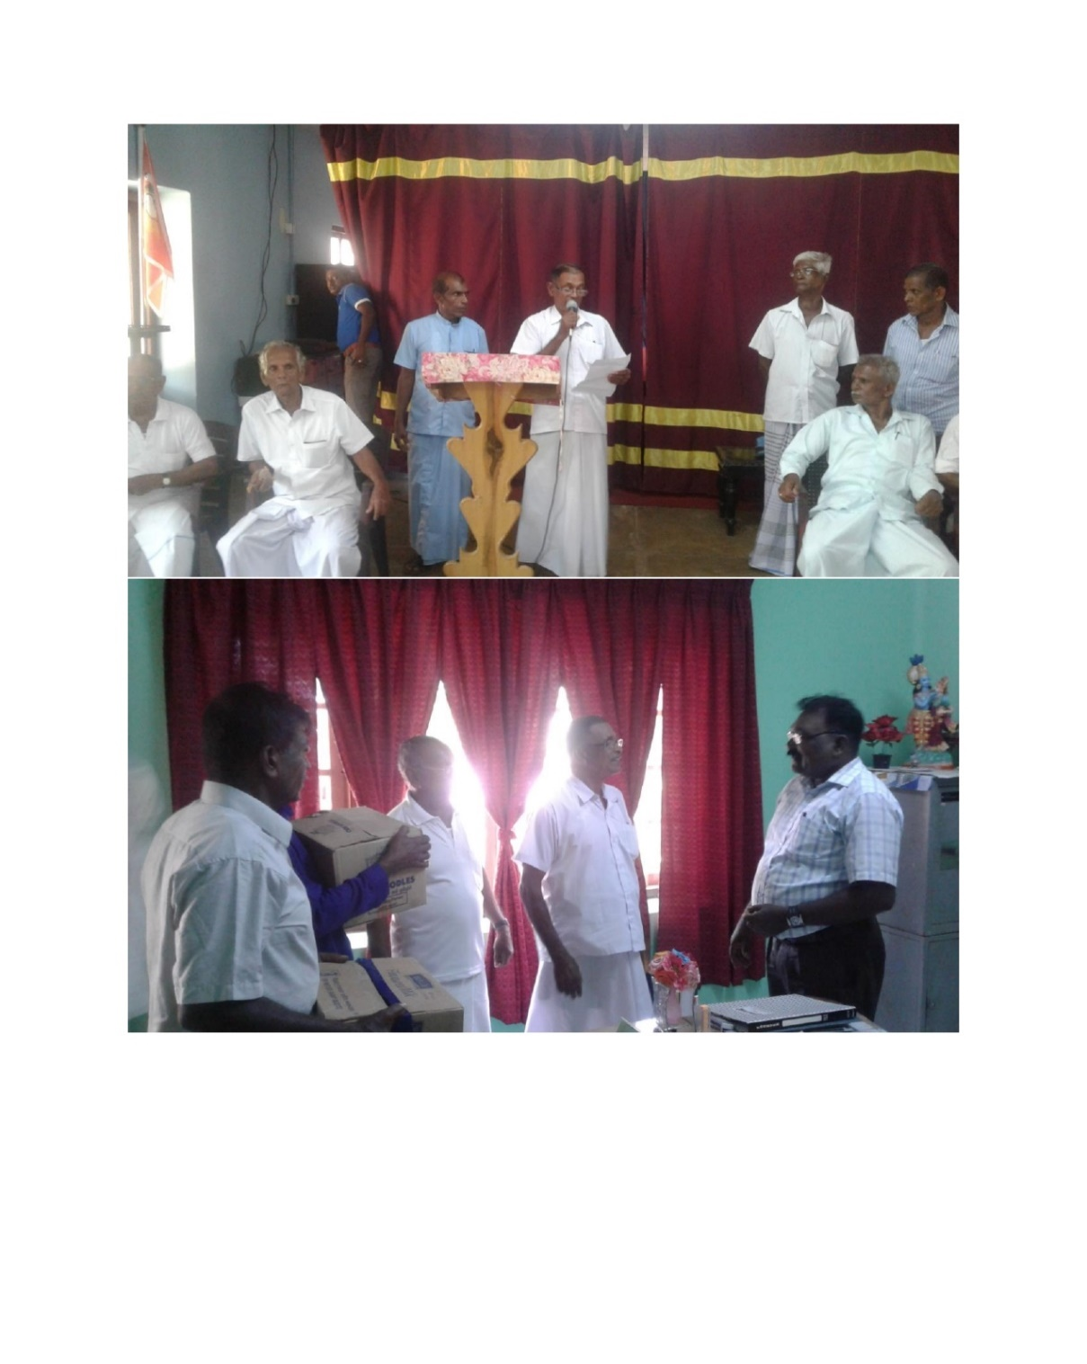

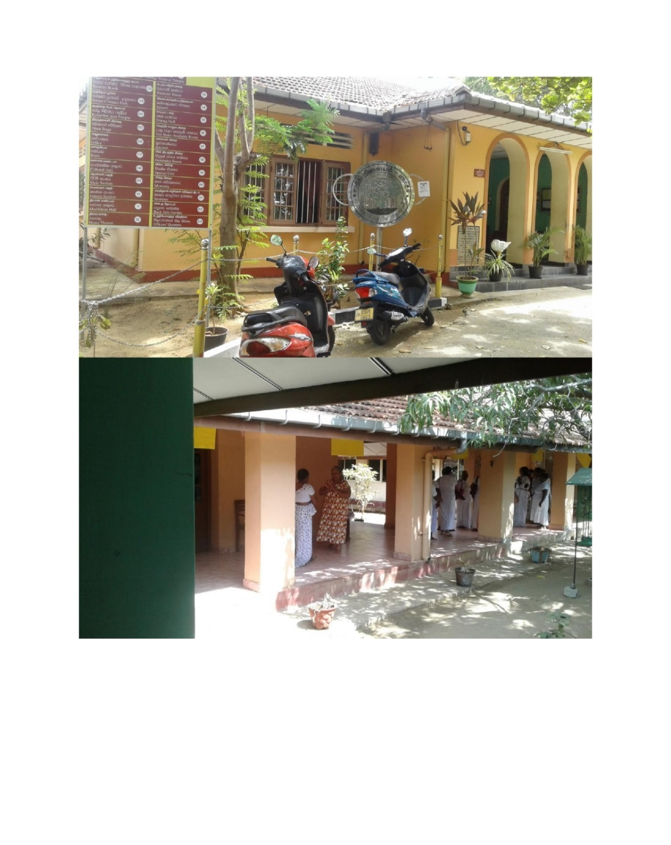From its inception, Berendina has been giving priority to the wellbeing of elders and closely work with Elders’ Clubs aiming to provide necessary requirements for their active and better functioning after retirement. Berendina organized an exposure visit for the 318 members of six Elders’ Clubs functioning in Horowpothana divisional secretariat and Ruwanweli Balamandalaya. Eight government officers also took part in the exposure visit as facilitators. The Elders’ Club members visited an elders’ home in Kaithadi at Jaffna in which members were capable of doing Palmyrah production as an income earning activity. The elders of Kaithadi elders home made the visitors aware of preparing handicrafts and other goods by using palmyrah leaves. The staff of the elders’ home were also very supportive and helped at their best to make this exposure visit a success. After the learning session, elders got together and conducted an entertainment session singing songs as well as experience sharing friendly conversations. The elders of Kaithadi elders’ home were so pleased to receive special gifts offered by their friendly visitors. This exposure visit paved the way for enriched cohesion between different societies hailing from different cultural backgrounds.

## Rural Community Empowerment and Development Project – Northern and Eastern Region (B171904)

The goal of the project is **to enhance socio economic status of selected vulnerable and marginalized people in north and east region** while **enjoying their rights by December 2019** i.e. 12,500 vulnerable families including elders, widows and differently abled persons in following Divisional Secretariat Divisions of 1. Batticaloa District: Manmuneli South West, Manmuneli West and Porateivu Pattu 2. Trincomalee District: Kinniya, Thampalakamam, Muttur and Serunuwara 3. Mullaitivu District: Puthukudiyiruppu and Maritimepattu.

It is expected to strengthen the capacity of the social institutions and enhance their services to the community through the proposed project. BDS will adopt both direct implementation and strategic partnership approaches in delivering the project inputs. The project has the following three outcomes.

1. Increased family income of farming and fishing communities – SD-01
2. Ensure access to and use of safe drinking water, sanitation, housing, health and health infrastructure facilities – SD-02
3. Strengthened capacity of local institutions/ CBOs (elders ‘clubs, water committees, and Differently abled persons’ society) to provide better services to plantation community and to
4. 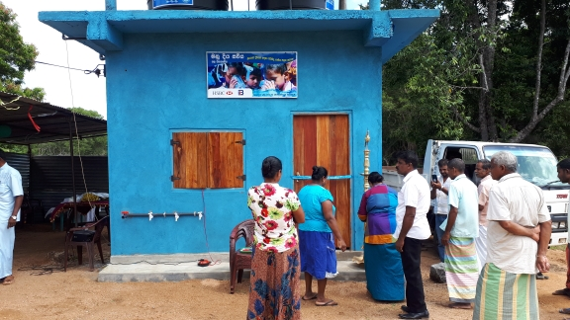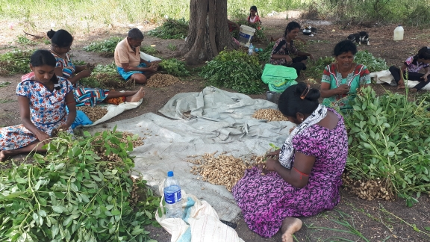voice for their basic rights – SD-03

Group based livelihood activity (Ground nut cultivation)

RO plan plant opening at Komarangadawela

at Pathinipuram -Thampalakamam

### **9.4.1 Summary of Activities and Progress**

| **Indicator** | **Annual Target** | **6-month Target** | **6-month Achieved** | **6-month Achieved vs. Target** | **Variance Explanation** | |
| --- | --- | --- | --- | --- | --- | --- |
| Output 1.1 Increased total production, crop and land productivity through use of better agronomic practices with sufficient irrigable water | | | | | | |
| No. of training programs conducted on best agronomic practices (steps farmers incorporate into their farm management systems to improve soil quality, enhance water use, manage crop residue and improve the environment through better fertilizer management) | 0 | 0 | 2 | - |  | |
| No. of participants on training programs conducted on best agronomic practices | 0 | 0 | 74 | - |  | |
| No. of training programs conducted on crop diversification | 0 | 0 | 2 | - |  | |
| No. of farmers received training on crop diversification | 0 | 0 | 74 | - |  | |
| Output 1.2 Upgraded economic rural infrastructures through community participation | | | | | | |
| No. of rural economic infrastructures upgraded/constructed with CBO participation | 29 | 20 | 1 | 5% | Ten projects are under construction | |
| No. of community members benefited through upgraded/constructed economic infrastructures | 2,088 | 1,440 | 80 | 6% |  | |
| Output 1.3 Increased market accessibility through reliable market linkages while upgrading existing infrastructure facilities | | | | | | |
| Provide technical training provided on identified VC interventions | 4 | 2 | 0 | 0% | Three training needs have been identified | |
| No. of farmers benefitted from technical training & inputs on value addition | 50 | 25 | 0 | 0% |  | |
| No. of FOs/FMSs received tools to reach markets through private partnerships | 32 | 15 | 3 | 20% | Tools are being purchased and distribution will be completed during 3rd quarter | |
| No. of farmers benefited through private partnerships | 850 | 400 | 100 | 25% |  | |
| Output 1.4 Increased fish catching in Batticaloa and Mullaitivu | | | | | | |
| No. of fisheries infrastructures upgraded with the participation fisheries societies/relevant govt. institutions | 4 | 2 | 1 | 50% |  | |
| No. of fisheries families benefited due to upgraded fisheries infrastructures | 170 | 86 | 108 | 126% |  | |
| Output 1.5 Increased alternative income sources based on local potentials & availability of resources | | | | | | |
| No. of tanks stocked with fingerlings | 13 | 13 | 11 | 85% |  | |
| No. of farmer/fisheries families benefited due to stocking of fingerlings | 400 | 400 | 422 | 106% |  | |
| No. of livelihood groups formed | 26 | 20 | 5 | 25% | Implementation of Aloe vera cultivations held until see the progress of previous project. | |
| No. of beneficiaries received inputs for group based alternative LH activities | 300 | 230 | 25 | 11% |  | |
| Creation of income generation opportunities through social business approach | 1 | 1 | 0 | 0% | Dairy processing plant was identified in Kinniya | |
| No. of beneficiaries received income generation opportunities through social business approach | 100 | 100 | 0 | 0% |  | |
| Output 2.1 Improved access to sanitation and housing facilities | | | | | | |
| No. of toilets constructed | 24 | 10 | 2 | 20% | Six identified and 2 in progress | |
| No. of houses constructed | 4 | 4 | 3 | 75% | Further two in progress | |
| Output 2.2 Increased availability of safe drinking water through social business approach & upgrading existing water schemes | | | | | | |
| No. of RO plants installed | 3 | 1 | 0 | 0% | 2 projects are identified and initial work has been accomplished. Projects will be completed in 4th quarter | |
| No. of families gained access to safe drinking water through RO plants | 450 | 150 | 0 | 0% |  | |
| No. of existing drinking water sources renovated | 5 | 3 | 0 | 0% | One construction is in progress and 2 more identified | |
| No. of families gained access to safe drinking water through renovated water sources | 60 | 36 | 0 | 0% |  | |
| No. of beneficiaries received water connection | 50 | 50 | 28 | 56% | It was difficult to identify beneficiaries under loan scheme so decided to give free connection. Hereafter this will be achieved | |
| Output 3.1 Improved human capacity of existing CBOs | | | | | | |
| No. of capacity building trainings conducted for CBOs | 9 | 6 | 2 | 33% | Gathering people for such trainings was a challenge due to the Easter attack | |
| No. of participants in capacity building trainings for CBOs | 270 | 180 | 82 | 46% |  | |
| No. of workshops conducted on positive attitudes/behavioral changes of office bearers | 7 | 4 | 1 | 25% | Gathering people for such trainings was a challenge due to the Easter attack | |
| No. of participants in workshops conducted on positive attitudes | 1050 | 600 | 286 | 48% |  | |
| No. of SCC strengthened and supported through BDS | 23 | 4 | 4 | 100% |  | |
| No. of vulnerable families given with monthly allowance | 155 | 155 | 178 | 115% |  | |
| Output 3.2 Improved structural capacity of existing CBOs | | | | | | |
| No. of CBOs received essential resources (furniture, tools and stationary) | 15 | 13 | 4 | 31% | CBOs identified and tools are being procured so distribution will be completed in 3rd and 4th quarter. | |
| Output 3.3 Reduced dependency of differently abled people & society of disabled people | | | | | |
| No. of district level coordination meeting facilitated | 18 | 3 | 2 | 67% |  | |
| No. of access facilities constructed for PWD | 5 | 0 | 0 | - |  | |
| No. of PWD received support | 250 | 0 |  | - |  | |
| No. of database developed/ books published with latest data on PWD | 3 | 0 | 0 | - |  | |

**Case Study 5**

Nellikkadu is a village in Ayithiyamalai North Grama Niladari division of Manmunai West DS division of Batticaloa District. Majority of the families in the area engage in farming for living. Ayithiyamalai Nellikadu – Vaikaladichenai farmer organization (FO) is a registered organization in the area which has 266 registered farmers who cultivate 755 acres of paddy land. They are engaging in paddy cultivation in both Maha and Yala seasons. They get irrigation water from Unnichchai major tank located nearly 20km away from the village.

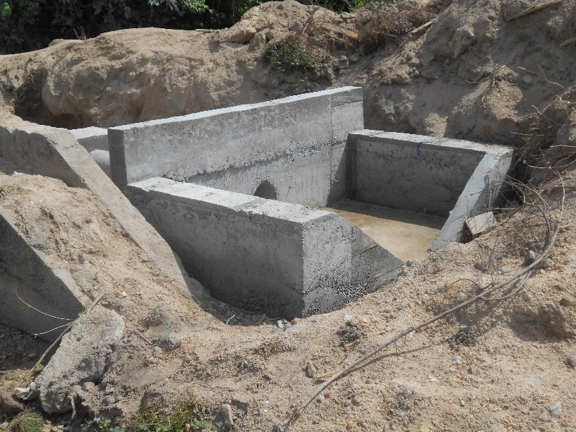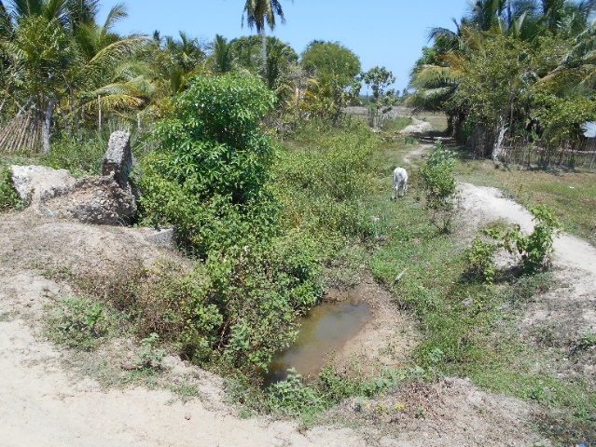Ayithimalai FO identified a construction of a turnout and desilting of 500m long channel as urgent needs of 27 farmers who were suffering with difficulties to get their 53 acres of farming lands irrigated. With the contribution of FO, BDS completed construction of turn out and desilting of channel giving new hopes to the farming community in the area. The total cost of the project was LKR 324,000 for which BDS has contributed LKR 226,000. The new turnout is helping the farmers to manage the water in a satisfactory way and utilize the resources in efficient manner. Also the channel attached to the structure was desilted to maintain better water flow.

1. Budget, Income and Expenses Progress

| **Project No** | **Outcome** | **Log frame Description** | **Budget (LKR)** | **Expense (LKR)** | **Burn Rate** |
| --- | --- | --- | --- | --- | --- |
|  |  |  |  |  |  |
| **Expenses Summary** | | | | | |
|  |  | **Plantation Project - B171901 (Nuwara Eliya District)** |  |  |  |
| B171901 | 1 | Improved health, sanitation, drinking water accessibility & housing conditions in project area |  |  |  |
| 20,356,500 | 3,349,001 | 16% |
| B171901 | 2 | Strengthened capacity of local institutions/ CBOs (Elders Clubs, differently abled persons’ societies & Water Consuming societies) to provide better services to communities in project area |  |  |  |
|  |  |  |
| 9,960,000 | 2,423,936 | 24% |
|  |  |  |
| B171901 | 3 | Quality of the project ensured (M & E) | 100,000 | 6,894 | 7% |
|  |  |  |  |  |  |
|  |  |  |  |  |  |
| **Total Direct Project Cost - Plantation - B171901 (Central)** | **30,416,500** | **5,779,831** | **19%** |
|  |  |  |  |
|  |  |  |  |  |  |
|  |  | **Rural Project (Central) - B171902 (Nuwara Eliya and Kegalle Districts)** |  |  |  |
| B171902 | 1 | Increased family income of vulnerable and marginalized communities project area |  |  |  |
| 1,685,000 | 295,289 | 18% |
|  |  |  |
| B171902 | 2 | Improved health, sanitation, drinking water accessibility & housing conditions in project area |  |  |  |
| 5,765,000 | 370,275 | 6% |
|  |  |  |
| B171902 | 3 | Strengthened capacity of local institutions/ CBOs (Farmer organizations, Fisheries societies, Women's societies, Elders Clubs, differently abled persons’ societies & Water Consuming societies) to provide better services to communities in project area |  |  |  |
|  |  |  |
|  |  |  |
| 4,092,000 | 2,018,000 | 49% |
|  |  |  |
| B171902 | 4 | Quality of the project ensured (M & E) | 100,000 | 16,631 | 17% |
|  |  |  |  |  |  |
|  |  | **Total Direct Project Cost - Rural - B171902 (Central)** | **11,642,000** | **2,700,195** | **23%** |
|  |  |  |  |  |  |
|  |  | **Rural (North Central) - B171903 (Anuradhapura District)** |  |  |  |
| B171903 | 1 | Increased family income of vulnerable and marginalized communities project area | 7,960,200 | 3,231,842 | 41% |
| B171903 | 2 | Improved health, sanitation, drinking water accessibility & housing conditions in project area |  |  |  |
| 9,301,000 | 4,596,730 | 49% |
|  |  |  |
| B171903 | 3 | Strengthened capacity of local institutions/ CBOs (Farmer organizations, Fisheries societies, Women's societies, Elders Clubs, differently abled persons’ societies & Water Consuming societies) to provide better services to communities in project area |  |  |  |
|  |  |  |
|  |  |  |
| 3,766,000 | 1,069,294 | 28% |
|  |  |  |
| B171903 | 4 | Quality of the project ensured (M & E) | 100,000 | - | 0% |
|  |  |  |  |  |  |
|  |  | **Total Direct Project Cost - Rural - B171903 (North Cantal)** | **21,127,200** | **8,897,866** | **42%** |
|  |  |  |  |  |  |
|  |  | **Rural (North and East) - B171904 (Batticaloa, Mullaitivu and Trincomalee Districts)** |  |  |  |
| B171904 | 1 | Increased family income of vulnerable and marginalized communities project area | 16,251,200 | 3,339,220 | 21% |
| B171904 | 2 | Improved health, sanitation, drinking water accessibility& housing conditions in project area | 7,140,000 | 890,570 | 12% |
| B171904 | 3 | Strengthened capacity of local institutions/ CBOs (Farmer organizations, Fisheries societies, Women's societies, Elders Clubs, differently abled persons’ societies & Water Consuming societies) to provide better services to communities in project area |  |  |  |
|  |  |  |
|  |  |  |
| 11,219,500 | 1,364,933 | 12% |
| B171904 | 4 | Quality of the project ensured (M & E) | 200,000 | - | 0% |
|  |  |  |  |  |  |
|  |  | **Total Direct Project Cost - Rural - B171904 (North and East)** | **34,810,700** | **5,594,723** | **16%** |
|  |  |  |  |  |  |
|  |  | **Activities to be handled by the Head Office** |  |  |  |
|  |  | Disaster Response Pool Budget | 1,000,000 | 2480 | 0% |
|  |  | Strategic Relationship with Stakeholders | 200,000 | 208,330 | 104% |
|  |  | Activities in non-project operating areas | 11,687,867 | - | 0% |
|  |  | **Total of activities handled by the Head Office** | **12,887,867** | **210,810** | **2%** |
|  |  |  |  |  |  |
|  |  | **Total Direct Project Cost (A)** | **110,884,267** | **23,183,425** | **21%** |
|  |  |  |  |  |  |
|  |  | **Project Supporting Cost** |  |  |  |
|  |  | Project Staff Costs | 31,689,621 | 15,102,543 | 48% |
|  |  | Program Related Travelling & Subsistence | 8,250,015 | 3,678,569 | 45% |
|  |  | Fixed Assets | 750,000 | 1,300,598 | 173% |
|  |  | Overheads | 7,676,695 | 4,354,100 | 57% |
|  |  |  |  |  |  |
|  |  | **Total Projects Supporting Cost (B)** | **48,366,331** | **24,435,810** | **51%** |
|  |  |  |  |  |  |
|  |  | **Government Taxes (C)** | **1,146,912** | 561,605 | **49%** |
|  |  |  |  |  |  |
|  |  | **Total BDS Program Cost** | **160,397,510** | **48,180,841** | **30%** |

|  |  |  |  |  |  |
| --- | --- | --- | --- | --- | --- |
| **Income Summary** | | | | | |
|  |  | **Funding Sources** | **Budget** | **Bi-annual Received Amount** | **Received %** |
|  |  |  |  |  |  |
|  |  | Berendina Stichting | 129,727,510 | 65,457,807 | 50% |
|  |  | Palm East - Lagoon Fishing Phase 3 | 1,070,000 | - | 0% |
|  |  | Interest Income from Investments | 2,500,000 | 3,907,451 | 156% |
|  |  | HSBC Bank | 7,000,000 | 1,400,000 | 20% |
|  |  | Housing Loan Recovery | 4,800,000 | 409,435 | 9% |
|  |  | Water connection Trinco BDS | 300,000 | 322,620 | 108% |
|  |  | Carried Forward from 2018 | 15,000,000 | 15,000,000 | 100% |
|  |  |  |  |  |  |
|  |  | **Total Income – BDS** | **160,397,510** | **86,497,313** | **54%** |